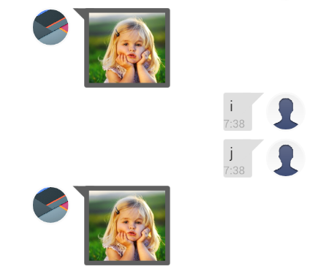

<https://stackoverflow.com/questions/30999867/android-custom-adapter-not-working-properly-for-chat-listview>

if (convertView == null) {

holder = new ViewHolder();

switch (type) {

case TYPE_ITEM_ME:

{

convertView = LayoutInflater.from(context).inflate(

R.layout.chat_listview_item_me, null);

}

break;

case TYPE_ITEM_OTHER:

{

convertView = LayoutInflater.from(context).inflate(

R.layout.chat_listview_item_other, null);

}

break;

}

convertView.setTag(holder);

} else {

holder = (ViewHolder) convertView.getTag();

}

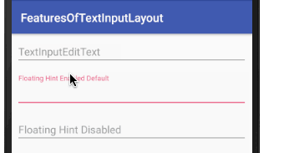

<https://www.journaldev.com/14748/android-textinputlayout-example>

compile 'com.android.support:design:25.3.1'

<android.support.design.widget.TextInputEditText

android:layout_width="match_parent"

android:layout_height="wrap_content"

android:hint="Floating Hint Enabled Default" />

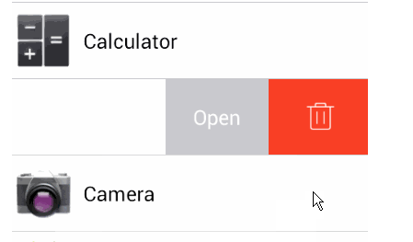

<https://androidexample365.com/a-swipe-menu-for-listview/>

dependencies {

compile 'com.baoyz.swipemenulistview:library:1.3.0'

}